Azure Databricks Setup Documentation

Goal
The goal of this setup is to configure an Azure Databricks workspace via the Azure Portal, set up a compute cluster, and prepare it to run workloads.

Steps to Set Up Azure Databricks
Step 1: Sign in to Azure Portal
- Open https://portal.azure.com in your browser.
- Sign in using your Azure account credentials.
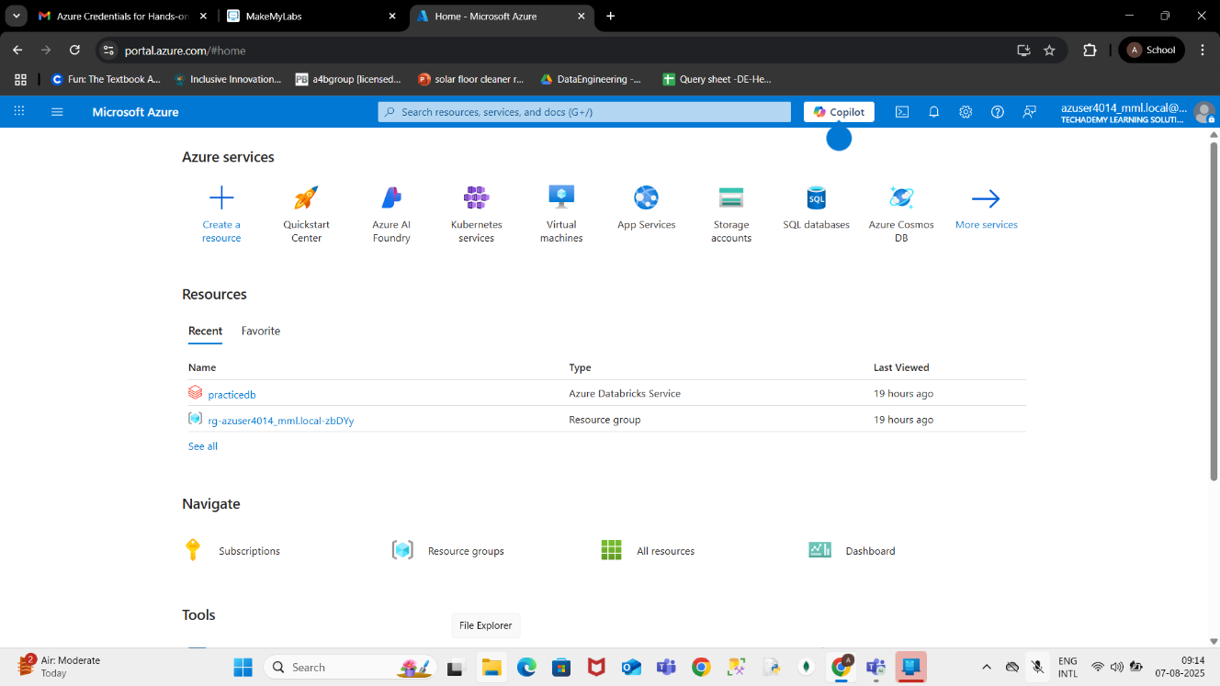

Step 2: Create a Resource
On the Azure Portal home page, click Create a resource from the left menu.
In the search bar, type Azure Databricks and select it from the list.
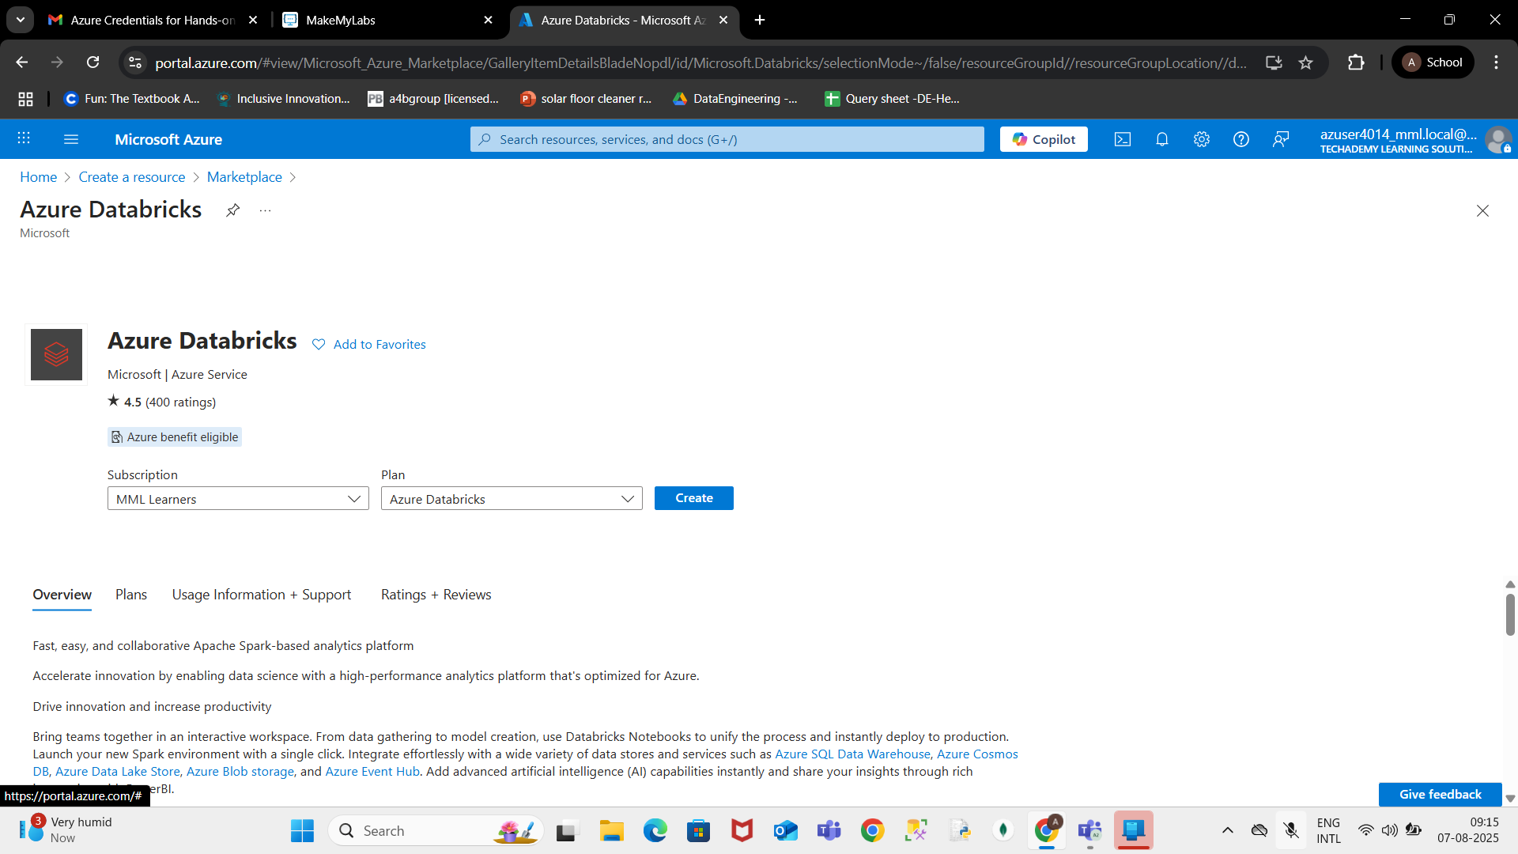

Step 3: Configure the Workspace
Click Create.
Fill in the required details:
Subscription: Select your subscription.
Resource Group: Select an existing one or create a new one.
Workspace Name: Enter a unique name.
Region: Choose the nearest region.
Click Review + Create and then Create.
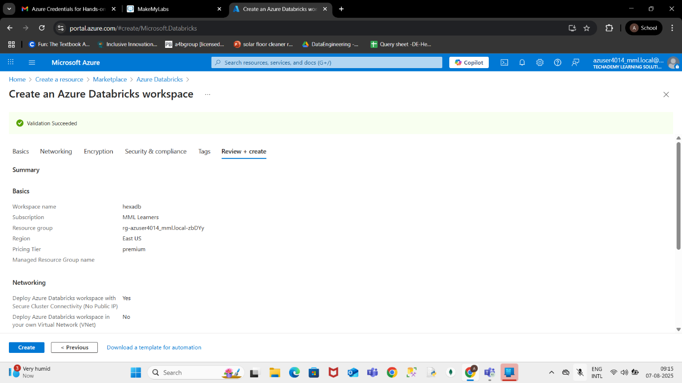

Step 4: Deployment Complete
Wait for the deployment to finish.
Once complete, click Go to resource.
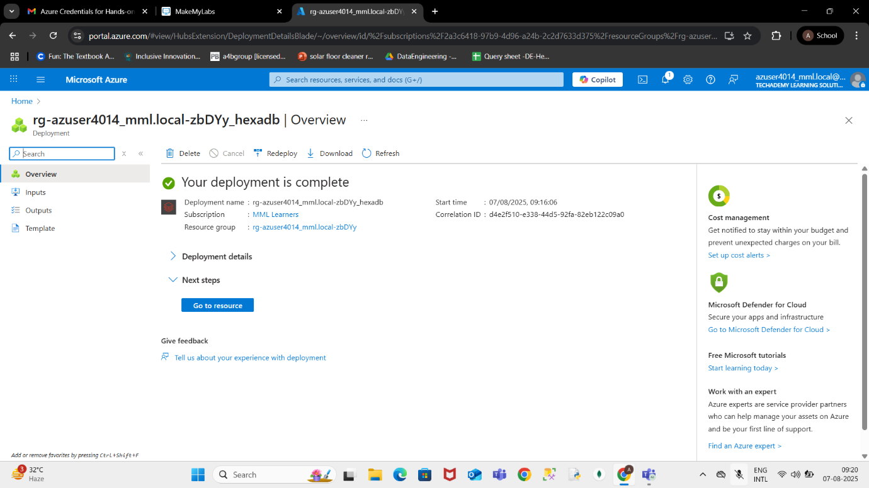

Step 5: Launch Azure Databricks Workspace
In the resource page, click Launch Workspace.
This will open the Databricks environment in a new tab.
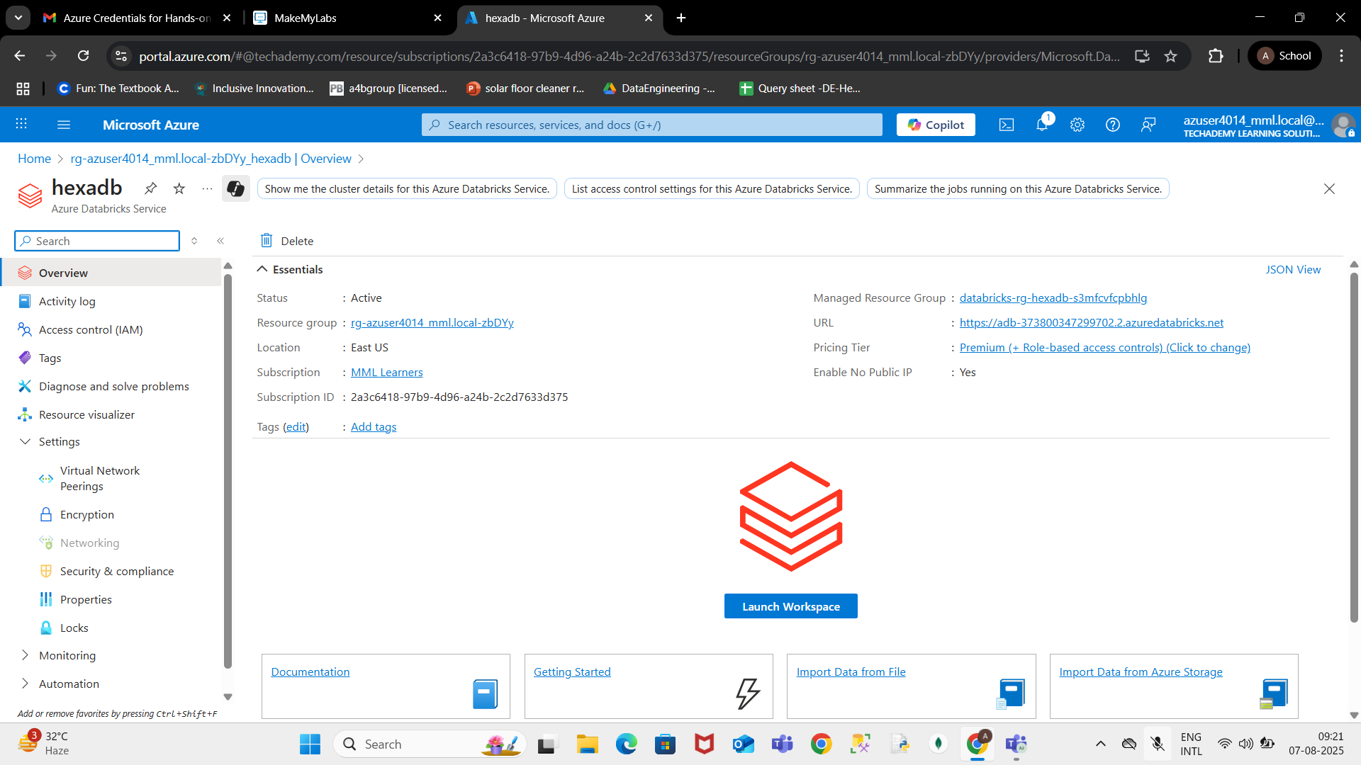

Step 6: Create a Cluster
In Databricks, click Compute in the left menu.
Click Create Cluster.
Fill in the cluster details and click Create.
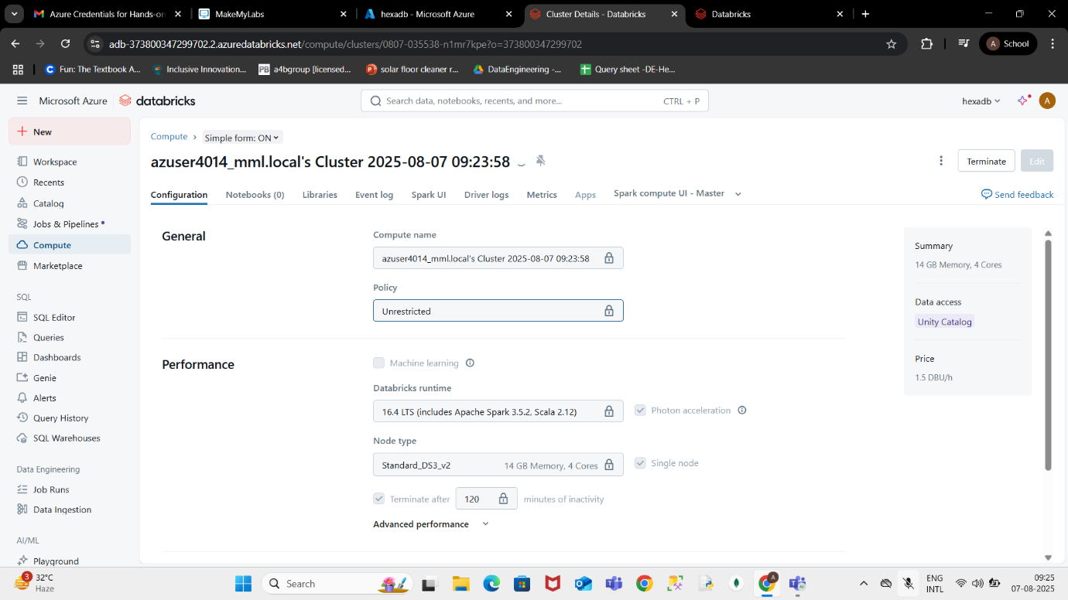

Conclusion
You have successfully set up Azure Databricks, created a workspace, and launched a compute cluster ready for running workloads.

